Hey, my name is Ionut Bogdan!

I worked for a CinemaReservationSistemApp:  
All the applications are generated with SPRING BOOT (Web, JPA, MySQL, Security), they are MAVEN projects.  
__________________________________________________________________________________  
- The main application is called "Cinema Reservation Sistem".

- The UI of this app is implemented 90% [with HTML + Freemarker Template Language].

- It has an InMemoryDB.

- On Admin Console Button you can do some CRUD operations (add/delete movies) and you can also list the movies from the InMemoryDB.

- The app has all the entities neccesary to implement reserveATicket functionality.

- Here are some screenshots from the running app:

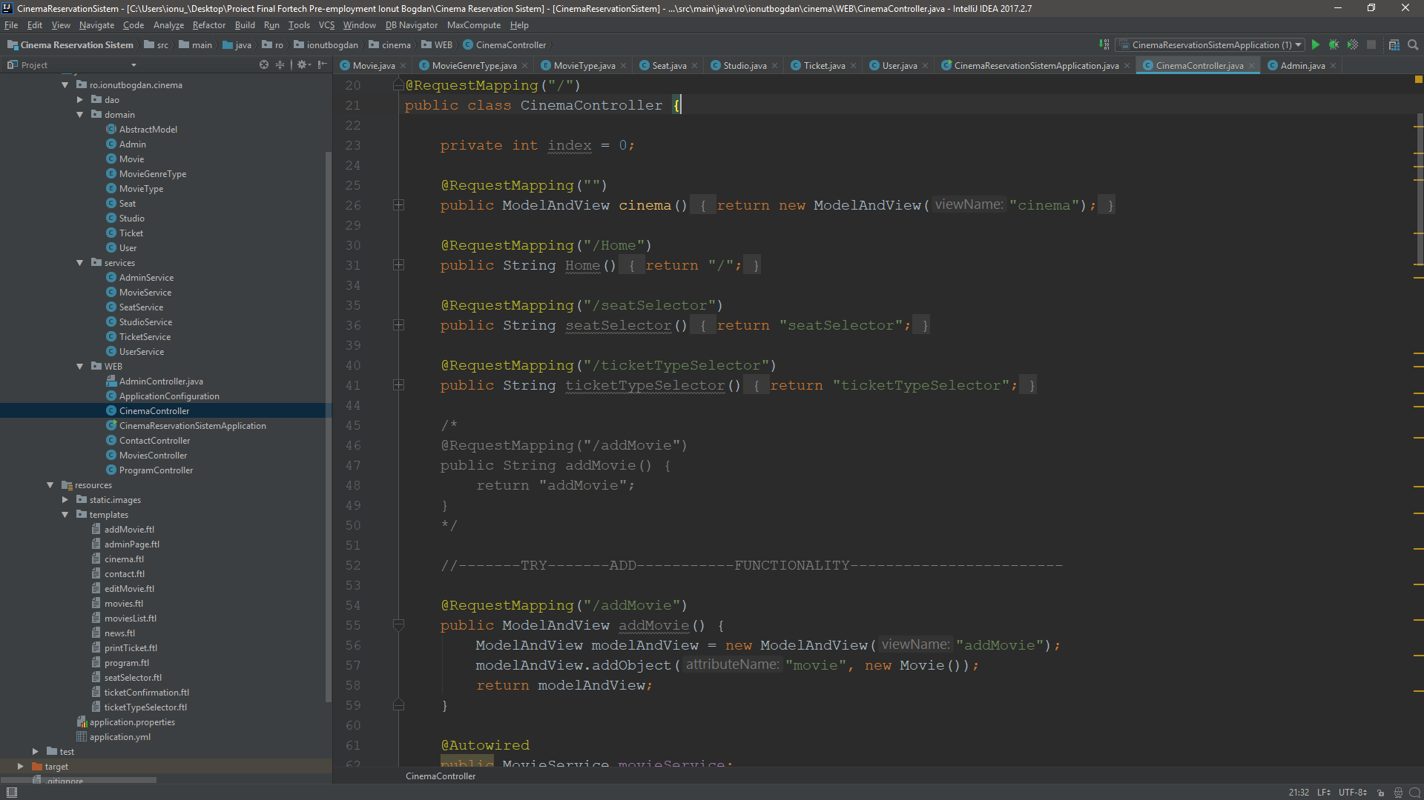

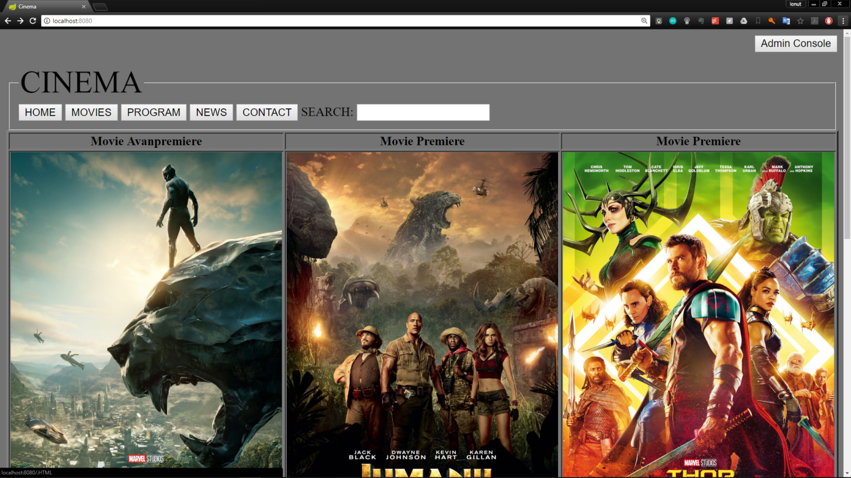

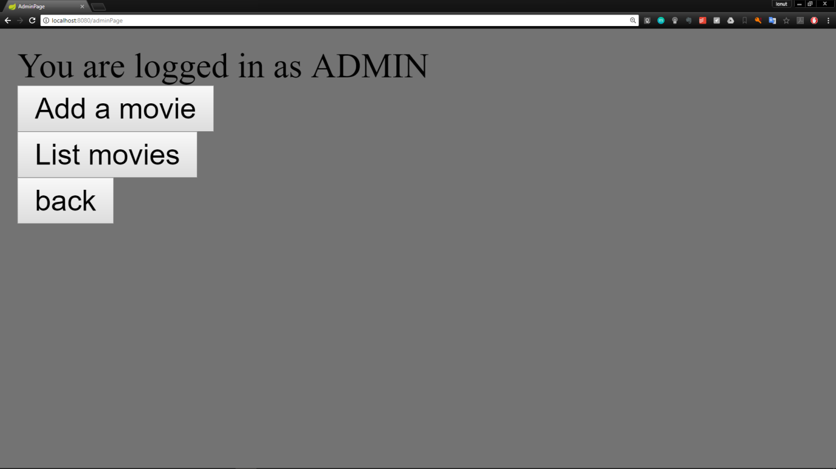

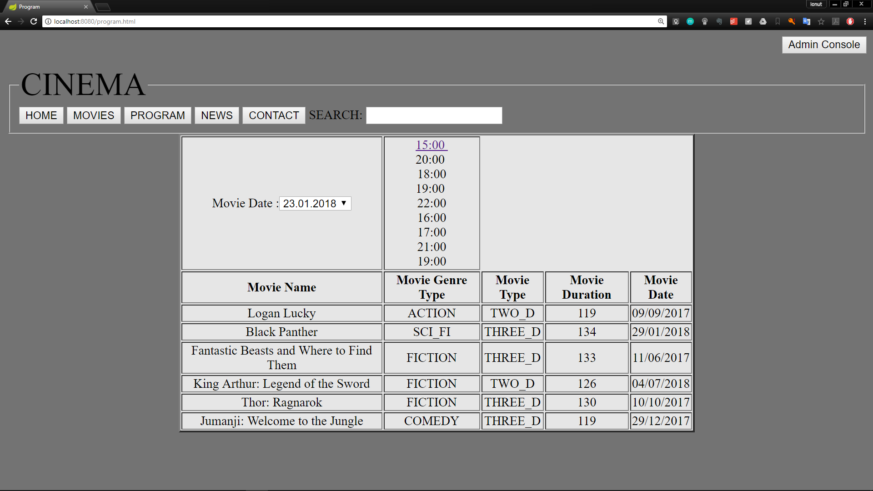

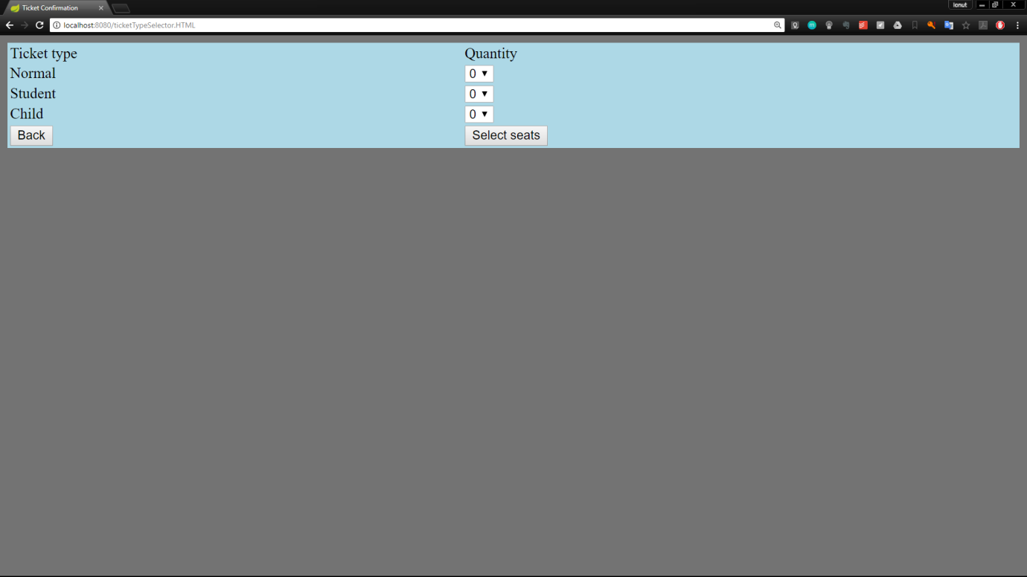

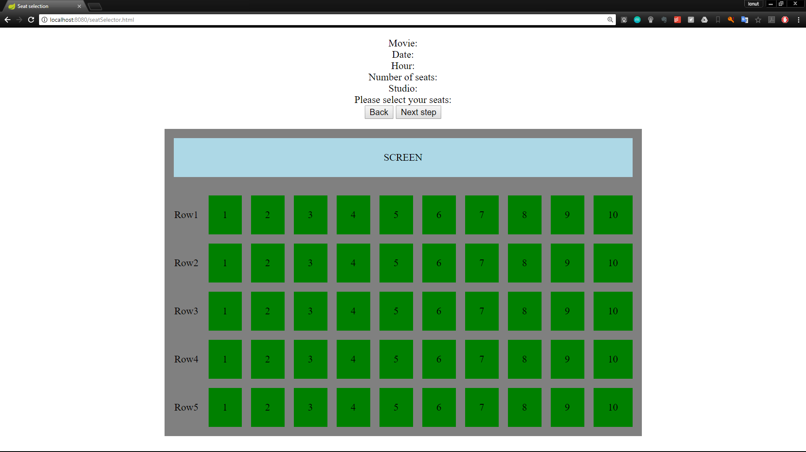

In this folders i also have some components to merge / implement in the main app.

This are as follows:

[**FIRST**] “Spring + SQL + DB + CRUD”

- This App Component has a MySQL DB connection.

- The DB has just one Table called "movie".

- For view we use JSP, we have 3 files: [index, edit, view].

- You can do all the cruds operations, and the information is persisted on the MySQL DB.

- I also used JpaRepository.

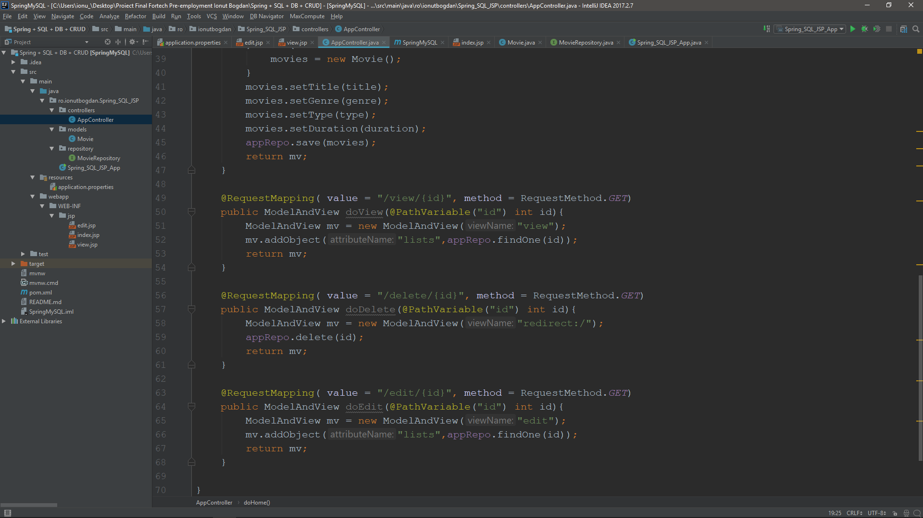

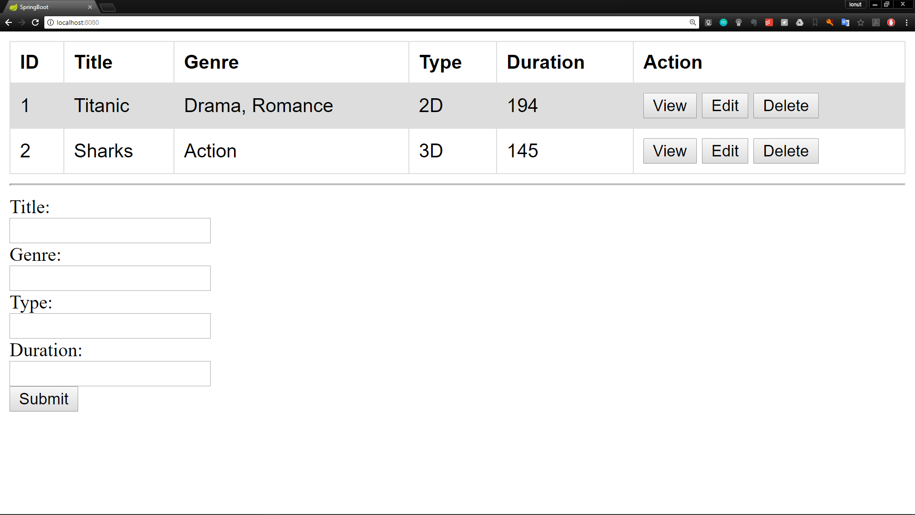

[**SECOND**] “Spring + Security + DB”

- In this second component that need to be implemented with the base app I have a simulation of Spring Security implementation.

- The app connects to a MySQL DB, that has 3 tables: [user, role, user_roles].

- There are 2 roles on the DB [ADMIN & USER].

- there are 2 links to access:

A. <http://localhost:8080/rest/salut/secured/all> (only admin user can acces it, it returns a string “Salut [cu security]”).

B. <http://localhost:8080/rest/salut/all> (all the users can access it, it returns a string: “Salut [fara security]”)

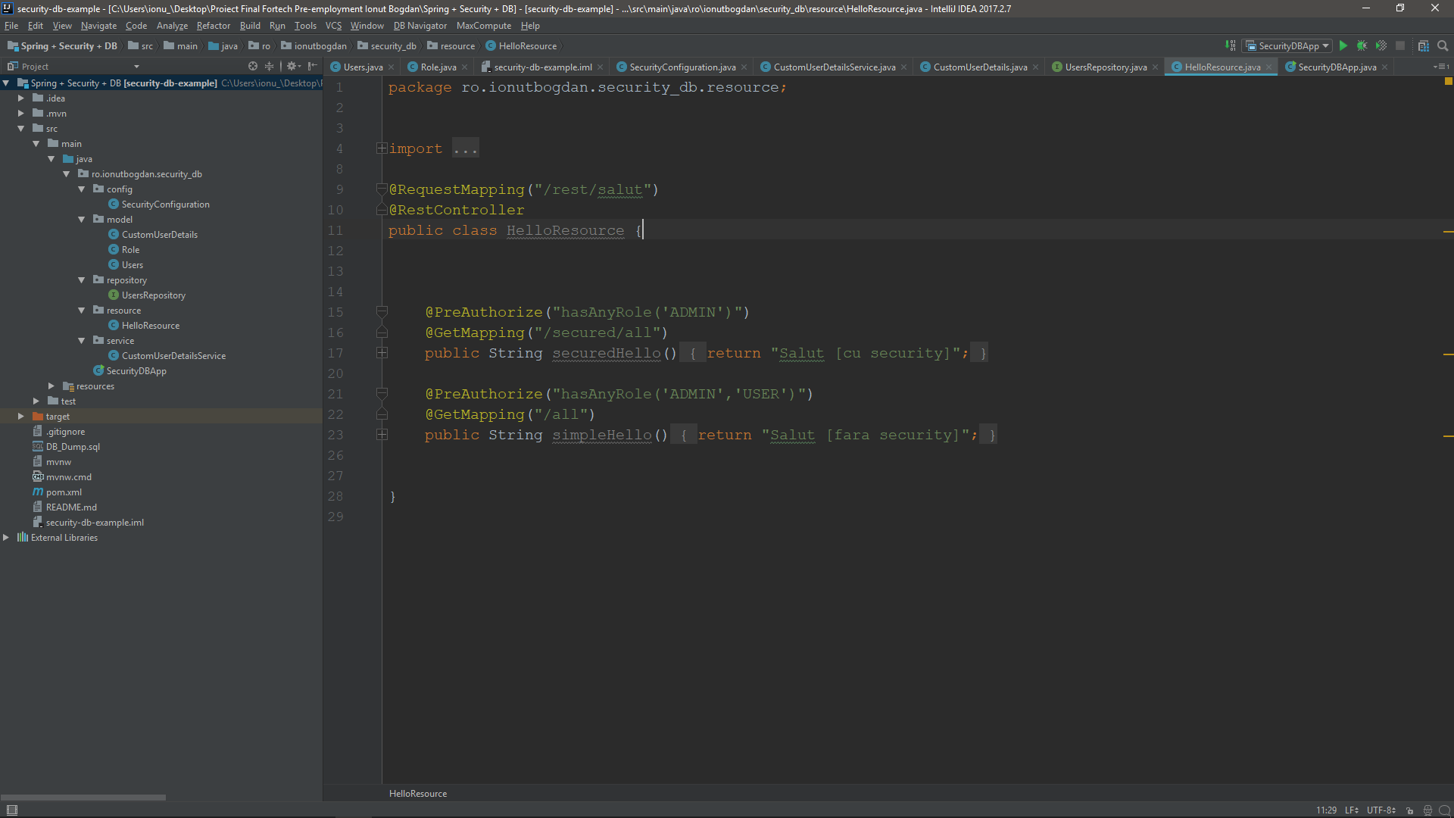

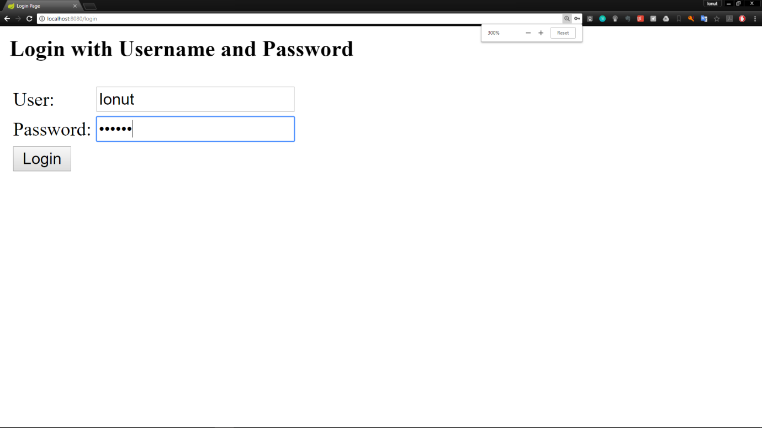

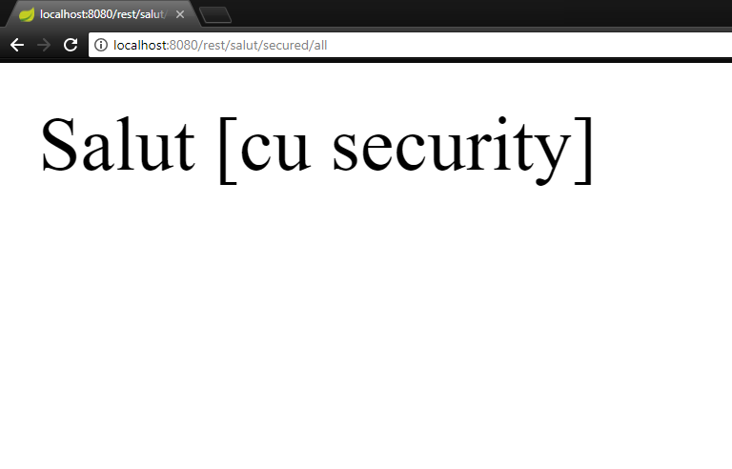

- I also have in folders the SQL files to create the tables i use.

- And I have also the presentation ☺, which ends with this slide:

